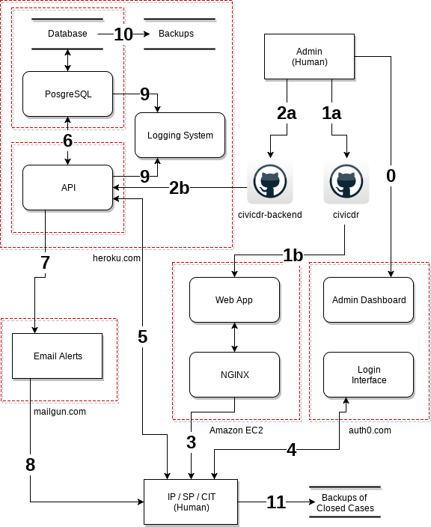

1. Admin compiles latest front-end CiviCDR Web App code and places it on Amazon EC2 server.
2. Admin deploys latest CiviCDR Back End and API code to Heroku.
3. Implementing Partners (IP), Service Providers (SP), and the CiviCDR Incident Response Team (CIT) go to community.civicdr.org which downloads the latest Web App
4. Users log-in using two-factor auth with the Auth0 LogIn Interface.
5. The Web App connects to the CiviCDR API as the user browses the platform.
6. The API interacts with a PostgreSQL database.
7. If users have notifications turned on the Back End will use Mailgun to send alerts.
8. Mailgun sends alerts to either a user's “default” or “incident specific” email address based upon the user's preferences.
9. All Back End systems send logs to Heroku’s internal logging system (which is configured to only keep the last few minutes of logs).
10. The Back End database is backed up daily.
11. IP’s and CIT’s can download ticket information for long-term record keeping before they are deleted.